**LAB 4**

**TASK 1**

**Code:**

#include <LiquidCrystal.h>

#include <Keypad.h>

LiquidCrystal lcd(12, 11,A0,A1,A2,A3);

//can also write as 12,11,A0,A1,A2,A3

const byte ROWS = 4;

const byte COLS = 3;

char keys[ROWS][COLS] =

{

// Four Rows of Keypad.

// Three Columns of Keypad

{'1','2','3'},

{'4','5','6'},

{'7','8','9'},

{'*','0','#'}

};

byte rowPins[ROWS] = {2,3,4,5};

byte colPins[COLS] = {8, 7, 6};

Keypad keypad = Keypad(

makeKeymap(keys), rowPins,

colPins, ROWS, COLS );

void setup()

{

//Serial.begin(9600);

lcd.begin(16, 2);

}

void loop()

{

char key =

keypad.getKey();

if (key)

{

//Serial.println(key);

lcd.print(key);

}

}

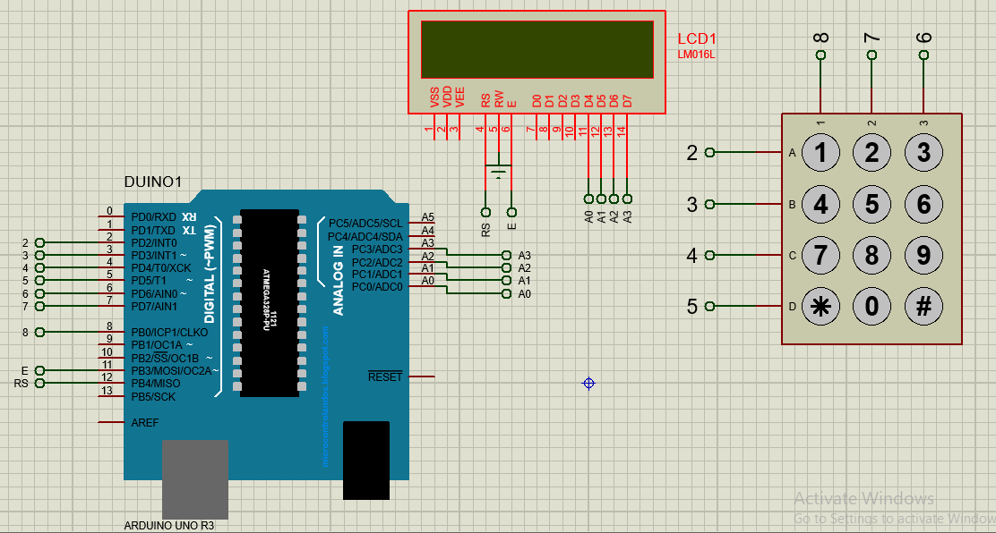

**Task 2:**

**Hardware pic**

**Code:**

#include <Keypad.h>

char* secretCode = "1234";

int position = 0;

const byte rows = 4;

const byte cols = 3;

char keys[rows][cols] =

{

{'1','2','3'},

{'4','5','6'},

{'7','8','9'},

{'*','0','#'}

};

byte rowPins[rows] = {2, 7, 6, 4};

byte colPins[cols] = {3, 1, 5};

Keypad keypad = Keypad(makeKeymap(keys), rowPins, colPins, rows, cols);

int redPin = 12;

int greenPin = 9;

void setup()

{

pinMode(redPin, OUTPUT);

pinMode(greenPin, OUTPUT);

setLocked(true);

}

void loop()

{

char key = keypad.getKey();

if (key == '*' || key == '#') // Reset Buttons.

{

position = 0;

setLocked(true);

}

if (key == secretCode[position])

{

position ++;

}

if (position == 4)

{

setLocked(false);

}

delay(100);

}

void setLocked(int locked)

{

if (locked)

{

digitalWrite(redPin, HIGH);

digitalWrite(greenPin, LOW);

}

else

{

digitalWrite(redPin, LOW);

digitalWrite(greenPin, HIGH);

}

}